


AB Bank Zambia

Monthly Report
June 2025

Contents
1. Executive Summary 2
1.1. Key Highlights: 2
1.1.1. Incident Volume & Trends: 2
1.1.2. Detection & Response Performance: 2
1.2. Incident Trends & Analysis: 3
1.3. High-Severity Incidents: 4
2. June Alerts & Incidents Overview 5
2.1. Overall Volume 5
2.2. Incidents Processing 5
2.3. Mean Time To Detect (MTTD) 5
3. Incidents Highlights 7
3.1. Top Incidents by type 7
3.2. Analysis of Key Incident Trends 7
1. MSSQL Account Logon Failure (542 incidents) 7
2. FortiGate Successful Login (320 incidents) 8
3. SQL Service Stopped (129 incidents) 8
4. Admin Account Logon Failure (123 incidents) 8
5. FortiGate UTM Alerts (71 incidents) 8
6. FortiGate Logon Failure (56 incidents) 8
7. User Account Modified (43 incidents) 8
8. ABBANK\rm_rasford.lembalemb Has Made Modifications to Group Policy Objects (42 incidents) 9
9. Incidents Summary Alert (39 incidents) 9
10. FortiGate Configuration change (36 incidents) 9
11. Authentication Attempt - Default Account (36 incidents) 9
3.3. High Severity 10
3.3.1. High Severity Incidents Analysis 10
1. ABBANK\rm_rasford.lembalemb Has Made Modifications to Group Policy Objects (75 incidents) 10
4. Cybersecurity Trends and Threats 11
4.1. Key Threats and Incidents 11
4.2. Regional Spillover and Infrastructure Risks 11
4.3. Government and Industry Response 11
5. Conclusion and Recommendations 13
5.1. Recommendations 13
5.2. Conclusion 13

Executive Summary
This security report provides an in-depth analysis of security incidents, alerts, and operational activities managed by Teknowledge for AB Bank Zambia during the reporting period. The findings highlight key security trends, detection and response performance, and proactive measures taken to enhance the organization’s security posture.

Key Highlights:

Incident Volume & Trends:
- A total of 1884 security incidents were processed in Microsoft Sentinel, encompassing both manually investigated cases and automated detections.
- The most prevalent security events still include MSSQL Account Login Failure, FortiGate Successful Login, SQL Service Stopped and Admin Account Logon Failure, highlighting the efficacy of identity protection, access control and identify targeted attacks.

Detection & Response Performance:
Mean Time to Detect (MTTD): 7 minutes and 06 seconds, ensuring timely identification of potential threats.
Additionally, the breakdown of MTTD by severity is as follows:
High Severity: 2 minutes and 21 seconds
Medium Severity: 7 minutes and 15 seconds
Informational: 5 minutes and 44 seconds

Mean Time to Resolution (MTTR): The average Mean Time to Resolution (MTTR) for this reporting period was 37 minutes across all severity levels. The screenshot below provides a detailed breakdown by severity, further highlighting the efficiency and responsiveness of our incident handling process.

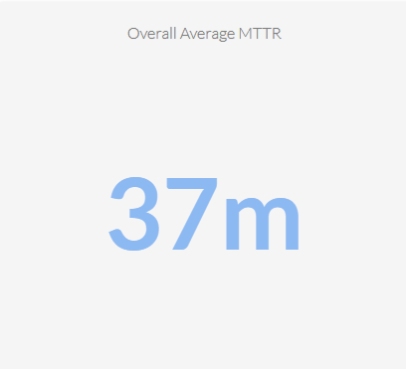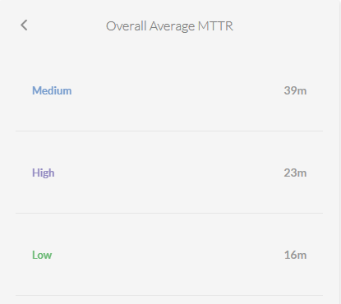

Average time to First Response: The average Time to First Response was 5 minutes. This reflects our enhanced alert triaging and faster engagement timelines. See the screenshot below for the breakdown.
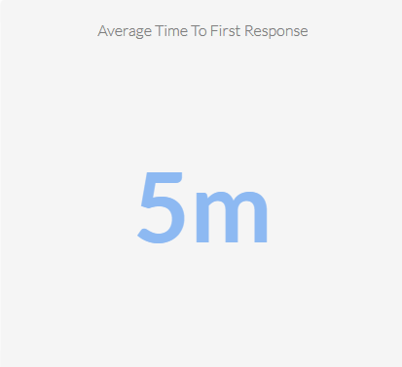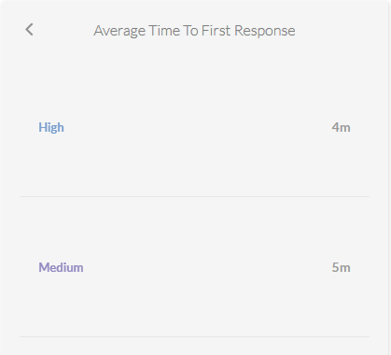

Incident Trends & Analysis:
The top recurring incident types identified in June accounted for 1437 of the total incidents. These incidents were mainly tied to MSSQL Account Logon Failure, FortiGate Successful login, SQL Service Stopped and Admin Account Logon Failure indicating High administrative activities and highlighting potential areas where policy enforcement could be strengthened.
The most frequent alerts were related to:
- MSSQL Account Logon Failure – 542
- FortiGate Successful login – 320
- SQL Service Stopped – 129
- Admin Account Logon Failure – 123
- FortiGate UTM Alerts – 71
All these incidents were thoroughly reviewed and remediated where necessary, helping to maintain a stable and secure environment.

High-Severity Incidents:
A total of 42 alerts were categorized as high severity, which entails Group Policy Modification. The high-severity case was fully investigated and confirmed to be authorized and resolved, with no signs of compromise.

June Alerts & Incidents Overview

Overall Volume
In the month of June, a total of 1884 incidents were handled on MS Sentinel. This volume includes both incidents that were manually processed by our security team and those that were automatically addressed through pre-configured automation protocols.

Incidents Processing
During the reporting period, TeKnowledge successfully monitored, detected, and responded to a total of 1884 security incidents within the AB Bank Zambia environment. The SOC team processed all incidents, ensuring a comprehensive approach to threat detection and response.

Mean Time To Detect (MTTD)
The average Mean Time to Detect (MTTD) for this reporting period was recorded at 7 minutes and 6 seconds

Incidents Highlights

Top Incidents by type
During the reporting period, TeKnowledge monitored and categorized security incidents, identifying the most prevalent issues within your environment. Below is a breakdown of the top incident types detected:
Incident Title | Sum of count
MSSQL Account Logon Failure | 542
FortiGate Successful Login | 320
SQL Service Stopped | 129
Admin Account Logon Failure | 123
FortiGate UTM Alerts | 71
FortiGate Logon Failure | 56
User Account Modified | 43
ABBANK\rm_rasford.lembalemb Has Made Modifications to Group Policy Objects | 42
Incidents Summary Alert | 39
FortiGate Configuration Change | 36
Grand Total | 1401

Analysis of Key Incident Trends
During this reporting period, TeKnowledge identified and categorized multiple security incidents within the AB Bank Zambia environment. The breakdown below highlights key trends, notable threat patterns, and actionable recommendations to improve detection and response capabilities
- MSSQL Account Logon Failure (542 incidents)
Description: This failure was majorly characterized by internal service account failing to connect to database server(s) due to changes in the SQL Server Administration or Password policy enacted in Database Service Accounts
Recommendation: All the MSSQL Account Logon failure attempt shows that the login requests were made from internal devices
-Review the MSSQL logs to identify the root causes of the Logon Failure from the accounts (The accounts will be made available on requests due to the sensitivity of the MSSQL Accounts)
- FortiGate Successful Login (320 incidents)
Description: A substantial number of successful logins to FortiGate firewalls were observed. While many may be legitimate, Some of the incidents were escalated for verification and confirmation.
Non-business hours login and Login from unusual IP addresses were also sent for verification, to determine the Authorization and activities at those times.
- SQL Service Stopped (129 incidents)
Description: Multiple SQL service stoppages were recorded, which was discovered to be Server maintenance, Application Updates, and could be network interruptions which impacted database availability.
Majority of the SQL Service incidents were escalated.
- Admin Account Logon Failure (123 incidents)
Description: A high number of failed logins attempts on administrative accounts were detected, suggesting potential unauthorized access attempts, brute-force attacks, or user misconfiguration.
Recommendation: Implement Just-in-Time (JIT) access controls, enforce Multi-Factor Authentication (MFA) for all admin accounts, and continuously monitor login failures for early detection of potential compromise.
- FortiGate UTM Alerts (71 incidents)
Description: This rule detects FortiGate Unified Threat Management (UTM) alerts by parsing Syslog messages that contain UTM alert indicators and identifying relevant details like source and destination IPs
Observation: Majority of the alerts were dropped after identifying that the requests originated from malicious IPs.
- FortiGate Logon Failure (56 incidents)
Description: This rule detects failed login attempts on FortiGate devices' administrative interface. It parses the Syslog messages for failure events, while excluding specific benign scenarios.
Observations:
- User Account Modified (43 incidents)
Description: This rule detects modifications made to user accounts in Active Directory by monitoring for Event ID 4738. It focuses on changes to user account attributes and identifies the account and subject responsible for the modification.
Observation: All User Account Modification Incidents were investigated and confirmed to be carried out by Authorized IT Admin.
- ABBANK\rm_rasford.lembalemb Has Made Modifications to Group Policy Objects (42 incidents)
Description: A user account (ABBANK\\rm_rasford.lembalemb) has made multiple modifications to Group Policy Objects (GPOs). This could indicate legitimate administrative activity or potentially unauthorized changes that may affect system configurations, user permissions, or security controls across the domain.
Feedback: All Group Policy-Modifications were confirmed to be done by Authorized IT Administrators, signifying an order in the requirements of operations.
- Incidents Summary Alert (39 incidents)
Description: This rule produces a summary count of incidents generated within a past duration of 12hrs
- FortiGate Configuration change (36 incidents)
Description: Configuration changes were detected on FortiGate devices, which may be related to legitimate administrative actions or unauthorized alterations that could impact network security posture.
Review: All FortiGate Configuration changes were made by Authorized IT Administrators.
- Authentication Attempt - Default Account (36 incidents)
Description: Repeated authentication attempts using default system accounts indicate potential brute-force or credential stuffing attacks by external threat actors attempting to exploit known defaults.
Recommendation: Enforce a lockout policy for repeated login attempts from suspicious IPs or sources.

High Severity
During the reporting period, Forty-two high-severity incidents were recorded. The incidents were thoroughly investigated and determined to be authorized and legitimate.

Incident Title | Sum of count_
ABBANK\rm_rasford.lembalemb Has Made Modifications to Group Policy Objects | 42
Grand Total | 42

High Severity Incidents Analysis
- ABBANK\rm_rasford.lembalemb Has Made Modifications to Group Policy Objects (75 incidents)
Review: All incidents were thoroughly investigated and correlated with known system roles. It was concluded to be Authorized and Legitimate Administrative tasks

Cybersecurity Trends and Threats
In June 2025, Zambia's cybersecurity landscape was marked by significant developments, including the enactment of new legislation and heightened concerns over digital threats. The introduction of the Cyber Security Act and the Cyber Crimes Act in April 2025 has continued to spark debate, with stakeholders expressing apprehension about potential overreach and implications for digital rights. Concurrently, the nation has faced a surge in cyber threats, particularly targeting the financial sector, underscoring the urgent need for robust cybersecurity measures.
iFex News

Key Threats and Incidents
The financial sector in Zambia has been increasingly targeted by cybercriminals employing sophisticated tactics. Reports indicate a rise in phishing attacks, ransomware, and trojans aimed at compromising financial institutions and their clients. Standard Chartered Bank Zambia highlighted these threats during the Cybertech Conference and Expo, emphasizing the need for enhanced security protocols to protect against such attacks.
Additionally, global cyber threats have had regional implications. June 2025 witnessed several high-profile cyber-attacks utilizing tools like Remcos and NetSupport RAT, which, while not directly linked to Zambia, underscore the pervasive nature of cyber threats and the importance of vigilance.
Efficacy News

Regional Spillover and Infrastructure Risks
Zambia's integration into the global digital ecosystem exposes it to regional and international cyber threats. The country's expanding digital infrastructure, while beneficial, also presents vulnerabilities that can be exploited by cybercriminals. The use of sophisticated malware and the increasing frequency of cyber-attacks in neighboring regions necessitate a proactive approach to cybersecurity. Ensuring the resilience of critical infrastructure and implementing comprehensive cybersecurity strategies are imperative to mitigate potential spill-over effects.
XAGE

Government and Industry Response
In response to the escalating cyber threats, the Zambian government has taken legislative action by enacting the Cyber Security Act and the Cyber Crimes Act in April 2025. These laws aim to strengthen the nation's cybersecurity framework but have been met with criticism from civil society organizations and legal experts who express concerns over potential infringements on digital rights and freedoms.
To address these concerns and foster dialogue, the government has engaged in public consultations and clarified the intent of the legislation, emphasizing the focus on national security and the protection of citizens' digital spaces. Furthermore, initiatives like the Cybertech Conference and Expo serve as platforms for stakeholders to collaborate on enhancing cybersecurity measures and promoting digital innovation.
Efficacy News, International Center for Not-For-Profit Law, The Agency Media

Conclusion and Recommendations

Recommendations
Review the MSSQL Server logs to identify the root causes of the Logon Failure from the accounts
Review the Recurring Admin Account logon failure to determine if the failures were malicious sources or from Legitimate App that requires a correct login credentials

Conclusion
The June 2025 reporting period marked a significant step forward in the security operations of AB Bank Zambia, with TeKnowledge continuing to provide dedicated 24/7 monitoring, incident detection, and rapid response through the Microsoft Sentinel platform. A total of 1884 alerts were processed—a decrease from the previous month—reflecting the effect of optimized analytical rules in the environment.
The most detected threats included MSSQL Account Logon Failure, Authentication Attempt - Default Account, FortiGate Successful Login, and user account modifications, underscoring the need for sustained vigilance in identity and access management as it relates to critical assets.
Teknowledge’s SOC demonstrated high operational efficiency, with the following key performance:
- Mean Time to Detect (MTTD): 7 minutes and 6 seconds
- Average Time to First Response: 5 minutes
- Average Mean Time to Resolution: 37 minutes

The high-severity incidents recorded during this period, involving Group Policy Object (GPO) modifications by legitimate administrator (ABBANK\rm_rasford.lembalemb).

Our incident type analysis revealed that identity-focused threats remain a dominant attack vector, with 757 alerts linked to account authentication failures and access-related anomalies.

